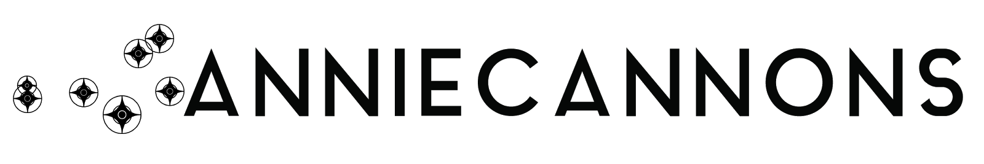

Celebrating April!

In San Francisco, April is the official start of spring! The hills are greener. Flowers bloom.
The month of April is also a time to recognize many causes. Look at the list below to see the different cause that are celebrated this month.

- Jazz Appreciation Month
- National Poetry Month
- National Poetry Writing Month
- Sexual Assault Awareness Month
- National Arab American Heritage Month
- National Child Abuse Prevention Month
- National Library Week
- National Volunteer Week
- National Park Week
- National Public Health Week

.

